**OCEANA COUNTY 4-H MARKET LIVESTOCK**

**EDUCATIONAL NOTEBOOK/RECORD**

###### GOAT PROJECT - 2025

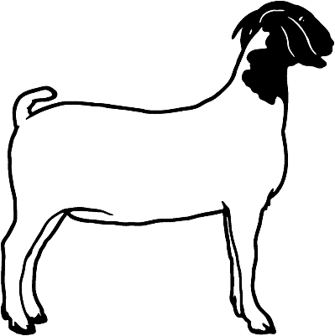

As a member of the 4-H Market Livestock Goat project you are required to submit your records as part of an educational project notebook in order to sell your animal at the 4-H Market Livestock Sale. **This notebook must be shown to the Oceana County 4-H Market Livestock Committee's Weighmaster at the time of weigh-in and then entered by you in the Educational Notebook Division of the Oceana County Fair on Entry Day.**

AGE: ________

**Remember:** The age you enter depends on how old you are or will be on Jan. 1, 2025

Number of years in project: ________

Use this sheet as the first page of your project record book. Fill it out completely.

**Please print or type neatly.**

NAME_______________________________________________________________________

4-H CLUB_____________________________________________________________________

BREED________________________________GOAT’S NAME__________________________

DATE OF BIRTH___________________ DATE RECORD STARTED_____________________

LOCATION WHERE ANIMAL IS RAISED __________________________________________



## **JUDGE’S SCORE/COMMENT SHEET**

## **(PLEASE DO NOT REMOVE, PLACE THIS SHEET IN SHEET PROTECTOR OR GLUE TO COVER). This sheet must be kept free for the judge to write their comments.**

## This sheet should help each 4-H’er understand their ribbon placing.

## A. **Specific educational value or worth**

## ___ All questions were answered completely

## ___ All calculations were correct

## ___ Calculations were incorrect

## ___ Questions were not completely answered

## ___ Questions were not answered (missed questions)

## B. **Notebook contains all project records**

## ___ Notebook contained all project records and were fully completed

## ___ Notebook contained additional project related information (research

## materials etc.)

## ___ Project records were incomplete

## ___There was no additional project related information

## C. **Accuracy, neatness and general appearance**

## ___Notebook was neat in appearance (typed/hand printed)

## ___Notebook pages were clean and stain free

___Notebook pages were in order and complete

___Notebook pages were out of order and missing pages

___Notebook was difficult to read and messy

__Notebook had wrinkled and stained pages

Other Comments: ______________________________________________________

____________________________________________________________

____________________________________________________________

# 4-H MARKET LIVESTOCK GOAT NOTEBOOK- 2025

**TABLE OF CONTENTS**

*Please keep your notebook in Table of Contents order.*

1. GENERAL GUIDELINE INFORMATION
2. JOURNAL OF CARE
3. PROJECT INFORMATION
4. PROJECT KNOWLEDGE
   1. Goat Parts Identification
   2. Wholesale Cuts
5. MY PROJECT INFORMATION

a) Your Project

b) 4-H Info

1. BUYERS NAMES
2. PICTURES OF YOUR PROJECT (1 page)
3. NON-CLUB/CLUB POINTS SHEETS

APPENDIXES (OPTIONAL):

1. PICTURES OF YOUR PROJECT (additional pictures)
2. FEED INFORMATION (example: feed labels etc.)
3. ADDITIONAL INFORMATION ABOUT YOUR PROJECT
   1. Information you found in reference materials
   2. Worksheets done with your 4-H Club
   3. Information you located off the internet
   4. Information gathered from your feed representative
   5. Any other information

*\* Include notes as to why you researched this information and found it*

*Valuable, link it to your project if possible.*

2025- Goat Record Book Page 1

This record is part of your 4-H Market Goat Project work. By keeping records up to date you will be able to see how much progress you make as you set goals and work to accomplish them. Write neatly and clearly. Feel free to add extra pages.

**PROJECT PICTURES**

Pictures are a required part of this notebook. Taking pictures of your animal project throughout the project will indicate how your animal has grown and developed. Add pictures to your notebook on a separate piece of paper.

**SCORING CRITERIA**

The following breakdown will be used during the judging process of all market livestock notebooks.

A. Specific educational value or worth **30%**

B. Creative way of showing what has been learned **10%**

C. Notebook contains all project records **50%**

D. Accuracy, neatness and general appearance **10%**

The Oceana County 4-H Market Livestock Committee encourages 4-H Leader and parent assistance with your project and project notebook. If you should have any questions, please contact the MSU Extension Office.

I, ____________________________ assisted ________________________ in

Parent/Leader/Adult Name 4-Her’s Name

understanding the questions and writing the answers. All answers are those of the 4-Her.

____________________________________

Signature of person helping with notebook

***If*** written help was needed

2025- Goat Record Book Page 2

**JOURNAL OF CARE SUMMARY**

The 4-H Market Livestock Committee is **requiring all**4-H Market Livestock members to complete the “Journal of Care” so the judge may see the time, effort and care you have put into learning about your animal. What did you do to keep your animal healthy and prepare them for fair?

**\*\*** *Include things such as walked, fed,* *washed, clipped, trimmed, foot care, health practices, medicines, general maintenance (cleaning living & feed area), halter broke, training, had vaccinated, etc.* ***\*\*please attach additional sheet for more room.***

_____________________________________________________________________________

_____________________________________________________________________________

_____________________________________________________________________________

______________________________________________________________________________

______________________________________________________________________________

______________________________________________________________________________

______________________________________________________________________________

______________________________________________________________________________

______________________________________________________________________________

______________________________________________________________________________

______________________________________________________________________________

______________________________________________________________________________

______________________________________________________________________________

______________________________________________________________________________

______________________________________________________________________________

______________________________________________________________________________

I,_______________________________, do attest and certify that this 4-Her has cared for

(property owner name-please print-if parent put parent’s name)

animal in a responsible manner while housed on my property. I also understand that integrity & responsibility are important to this 4-H experience.

____________________________________ ________ _________________

Signature of Property Owner or Parent Date

If housed on own property.

2025- Goat Record Book Page 3

**PROJECT INFORMATION**

The start of the project will be the date the 4-Her placed the animal on feed, not any later than June 1st of the current year. The end of the project will be weigh-in day at the Fair.

## Project Start Date ______________ Project End Date ________________ Fair Haul In

What month was your lamb born? __________________________

Please complete the following chart about your project.

|  |  |  |  |  |  |  |  |
| --- | --- | --- | --- | --- | --- | --- | --- |
| 4-H Ear Tag  Number | Breed | Gender | Date of Purchase | Price or value | Estimated Starting Weight | Ending/FinalWeight  **(FW)** | Total Pounds Gained |
|  |  |  |  |  |  |  |  |

**Note: Total pounds gained = ending weight – starting weight**

**MONTHLY FEED RECORD & EXPENSES**

|  |  |  |  |  |
| --- | --- | --- | --- | --- |
| Month | Type of feed used-  (grain, roughage, etc.) | Supplements  (if any used) | Amount  (indicate lbs., bales etc.) | Cost of feed used for the month |
| April |  |  |  |  |
|  |  |  |  |  |
|  |  |  |  |  |
| May |  |  |  |  |
|  |  |  |  |  |
|  |  |  |  |  |

2025- Goat Record Book Page 4

**MONTHLY FEED RECORD & EXPENSES (cont.)**

|  |  |  |  |  |
| --- | --- | --- | --- | --- |
| Month | Type of feed used-  (grain, roughage, etc.) | Supplements  (if any used) | Amount  (indicate lbs., bales etc.) | Cost of feed used for the month |
| June |  |  |  |  |
|  |  |  |  |  |
|  |  |  |  |  |
| July |  |  |  |  |
|  |  |  |  |  |
|  |  |  |  |  |
| August |  |  |  |  |
|  |  |  |  |  |
|  |  |  |  |  |
| Column Totals |  |  |  |  |

**Total Feed Costs for Project $________________**

2025- Goat Record Book Page 5

**EXPENSES OTHER THAN FEED**

The 4-H Market Livestock Committee would like you to keep a running list of all of your expenses -- *veterinary charges, bedding, insecticides, trucking, insurance, interest paid on money borrowed, housing etc. Even if your parents pay for these items, figure out how much your animal needs and or uses as this is an expense of YOUR project.*

|  |  |  |  |  |  |  |  |  |  |  |  |
| --- | --- | --- | --- | --- | --- | --- | --- | --- | --- | --- | --- |
|  | **Vet**  **Charges** | **Bedding** | **Insecticides** | **Equipment** | **Trucking** | **Housing/Rent** | **Show prep or**  **Clipping** | **Advertising/**  **Marketing** | **Miscellaneous (specify)** | **Buyer Recognition** | **MONTHLY TOTAL** |
| **APR** |  |  |  |  |  |  |  |  |  |  |  |
| **MAY** |  |  |  |  |  |  |  |  |  |  |  |
| **JUNE** |  |  |  |  |  |  |  |  |  |  |  |
| **JULY** |  |  |  |  |  |  |  |  |  |  |  |
| **AUG** |  |  |  |  |  |  |  |  |  |  |  |
| **TOTALS** |  |  |  |  |  |  |  |  |  |  |  |

2025- Goat Record Book Page 6

**PROJECT EFFICIENCY INFORMATION**

***(using figures from page 3,4 and 5)***

Value of Animal at Time of Purchase = ___________

__________________ ÷ ______________ = __________________________

Total lbs. of Gain Days on Feed Average Daily Rate of Gain

(from page 4)

_______________ ÷ __________________ = __________________________

Total Feed Cost Total lbs. of gain Feed Cost per lbs. of Gain

______________________÷__________________=___________________________

Total lbs. of feed fed Total lbs. of gain Lbs. of Feed Fed per lb. of Gain

_________________ + ______________ + ______________ = ______________ **(TE)**

Total Feed Expense Cost of Animal Other Expenses Total Project Expense

Goats are sold by the pound at a Large Animal Sale Auction. Find out what bid price (per lb.) you need to get at the Large Market auction to **breakeven (BE)** on your market lamb project.

__________________÷____________________= ____________________________

Total Expenses **(TE)** Final Weight **(FW)** Break Even Price **(BE)**

(or total cost per lb. to raise your animal)

What is the current selling price of goats (per lb.)? _____________________________

Where did you find the current selling price? ________________________________

(if your source was a person, ask them where they got this information)

Would you have been able to make a profit selling on the open market? __________

Why or why not? _______________________________________________________

_____________________________________________________________________

_____________________________________________________________________

2025- Goat Record Book Page 7

**PROJECT KNOWLEDGE**

**PARTS OF THE GOAT IDENTIFICATION**

**Ages 8-12: Complete 10 labels Ages 13-15: Complete 30 labels Ages 16-19: Complete all labels**

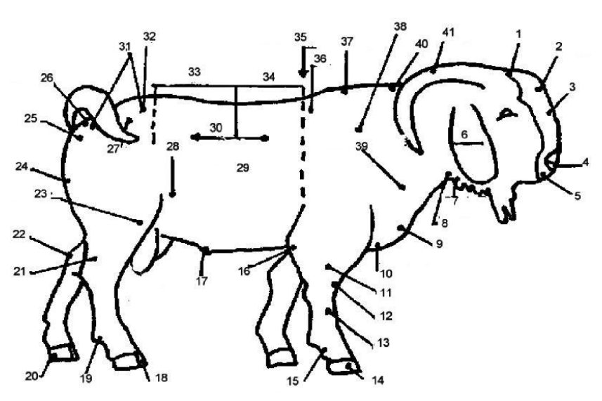

|  |  |  |  |  |  |
| --- | --- | --- | --- | --- | --- |
| 1. | 9. | 17. | 25. | 33. | 41. |
| 2. | 10. | 18. | 26. | 34. |  |
| 3. | 11. | 19. | 27. | 35. |  |
| 4. | 12. | 20. | 28. | 36. |  |
| 5. | 13. | 21. | 29. | 37. |  |
| 6. | 14. | 22. | 30. | 38. |  |
| 7. | 15. | 23. | 31. | 39. |  |
| 8. | 16. | 24. | 32. | 40. |  |

2025- Goat Record Book Page 8

**KNOWING YOUR GOAT-PROJECT KNOWLEDGE**

**WHOLESALE CUTS**

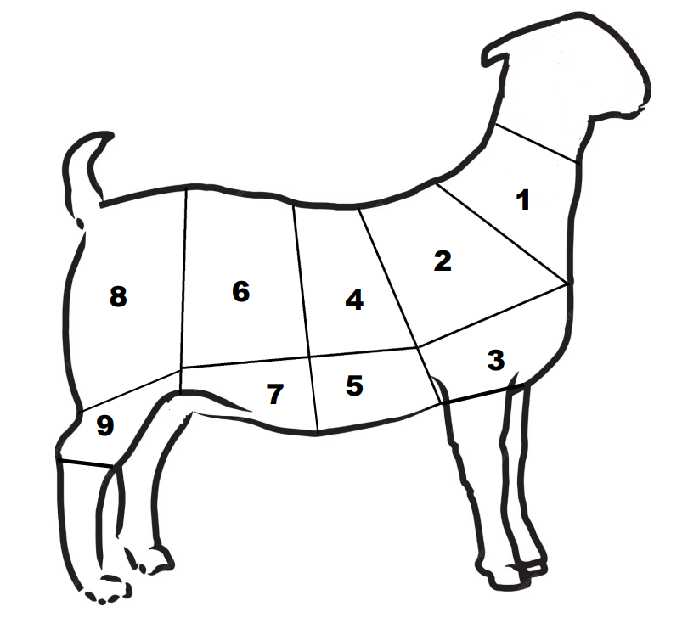

|  |  |  |
| --- | --- | --- |
| 1. | 4. | 7. |
| 2. | 5. | 8. |
| 3. | 6. | 9. |

2025- Goat Notebook Page 9

**your project**

Please describe your year with your project. Things you can include: How did you select your lamb, are you happy with your project, the best and worst features of your lamb project, and would you do the project again.

______________________________________________________________________

______________________________________________________________________

______________________________________________________________________

______________________________________________________________________

______________________________________________________________________

______________________________________________________________________

______________________________________________________________________

______________________________________________________________________

______________________________________________________________________

______________________________________________________________________

______________________________________________________________________

______________________________________________________________________

______________________________________________________________________

______________________________________________________________________

______________________________________________________________________

______________________________________________________________________

______________________________________________________________________

______________________________________________________________________

2025- Goat Notebook Page 10

**4-H INFORMATION**

**The 4-H Pledge**

**I pledge…..**

**___________________________________________________________________________________,**

**___________________________________________________________________________________,**

**___________________________________________________________________________________,**

**___________________________________________________________________________________,**

**___________________________________________________________________________________,**

**___________________________________________________________________________________.**

**The 4-H MOTTO:**______________________________________________________

**List 1 way that you helped or taught others this year:**

_____________________________________________________________________

_____________________________________________________________________

________________________________________________________________________________________________________

________________________________________________________________________________________________________

POTENTIAL BUYERS NAMES

As part of your 4-H Market Livestock Project, you must personally contact at least five potential buyers before the Oceana County Fair. You are encouraged to seek two new buyers that have not been asked or submitted before. You also must have at least three different buyers than those of your siblings in the market livestock project. Please confirm with your buyers their accurate mailing address (example: post office box vs. a street address). The information on page 11 must be completed and taken to the Oceana County MSU Extension Office on or before the due date where it will be **copied** and used to send out letters to your potential buyers. This page will remain in your notebooks. This is a Market Livestock Committee rule. Failure to comply will result in not being able to sell your animal in the 4-H Market Livestock Sale.

2025-Goat Record Book Stamp _______________

PAGE 11 Staff _______________

**4-H MARKET LIVESTOCK POTENTIAL BUYER’S LIST**

**GOAT PROJECT**

Name______________________________ Club_________________________

***Please print business names and complete addresses clearly.***

1. Contact Name ________________________________________________­­____

Business Name ____________________________________________________

**Mailing** Address _________________________City__­­­­­­­­__­­­­­­­_____________Zip_____

Phone _______________________ After Hours Phone______________________

Mailing Preference (Please Check One): Email ____ Postal Delivery ____

Email ____________________________________________________________

Signature__________________________________________________________

2. Contact Name ________________________________________________­­____

Business Name ____________________________________________________

**Mailing** Address _________________________City__­­­­­­­­__­­­­­­­_____________Zip_____

Phone _______________________ After Hours Phone______________________

Mailing Preference (Please Check One): Email ____ Postal Delivery ____

Email ____________________________________________________________

Signature__________________________________________________________

3. Contact Name ________________________________________________­­____

Business Name ____________________________________________________

**Mailing** Address _________________________City__­­­­­­­­__­­­­­­­_____________Zip_____

Phone _______________________ After Hours Phone______________________

Mailing Preference (Please Check One): Email ____ Postal Delivery ____

Email ____________________________________________________________

Signature__________________________________________________________

(Must be stamped by the MSU Extension Office)

2025-Goat Record Book Stamp _______________

PAGE 12 Staff _______________

**If you would like to contact additional buyers you can use this page. If not please throw this page out.**

**Contact Name** ________________________________________________­­____

Business Name ____________________________________________________

**Mailing** Address _________________________City__­­­­­­­­__­­­­­­­_____________Zip_____

Phone _______________________ After Hours Phone______________________

Mailing Preference (Please Check One): Email ____ Postal Delivery ____

Email ____________________________________________________________

Signature__________________________________________________________

**Contact Name** ________________________________________________­­____

Business Name ____________________________________________________

**Mailing** Address _________________________City__­­­­­­­­__­­­­­­­_____________Zip_____

Phone _______________________ After Hours Phone______________________

Mailing Preference (Please Check One): Email ____ Postal Delivery ____

Email ____________________________________________________________

Signature__________________________________________________________

**Contact Name**  ________________________________________________­­____

Business Name ____________________________________________________

**Mailing** Address _________________________City__­­­­­­­­__­­­­­­­_____________Zip_____

Phone _______________________ After Hours Phone______________________

Mailing Preference (Please Check One): Email ____ Postal Delivery ____

Email ____________________________________________________________

Signature__________________________________________________________

2025- Goat Notebook Page 13

**YOUR PROJECT PICTURES**

(Please use this page for your project pictures. If you have more than 1 page of pictures please use the appendix section to include those pictures).

**NON-CLUB POINTS**

**8 YEARS OLD & UP MUST COMPLETE- MARKET LIVESTOCK ANIMAL ASSOCATION PROJECT ATTENDANCE RECORD**

***(This must be filled out before presenting for signatures at the office.)***

|  |  |  |  |  |
| --- | --- | --- | --- | --- |
| **MEETING NAME** | **LOCATION** | **DATE** | **POINTS** | **SIGNATURE OF LEADER, SUPERINTENDENT OR MSU STAFF** |
|  |  |  |  |  |
|  |  |  |  |  |
|  |  |  |  |  |
|  |  |  |  |  |
|  |  |  |  |  |
|  |  |  |  |  |
|  |  |  |  |  |
|  |  |  |  |  |
|  |  |  |  |  |

Please note: This form must be included with your notebook and turned into the weigh master on entry day of the Fair. **BEFORE SEEKING SIGNATURES AT MSU EXTENSION – MEETING NAME AND DATE MUST BE COMPLETED**. You need to accumulate **nine (9) points** to be allowed to sell your animal. **Six (6)** of these **nine (9) points** must come from club meetings. **Two (2)** of these 9 points are non-club points must be earned from attending various 4-H events and activities. **One (1)** of these 9 points must be a fairgrounds workbee point. See your leader, the MSUE office, or online at <https://www.canr.msu.edu/oceana/oceana_county_4_h/oceana_4_h_market_livestock> for a listing of approved nonclub points.

**CLUB POINTS**

**MARKET LIVESTOCK ATTENDANCE RECORD- ALL AGES MUST COMPLETE**

***(This must be filled out before presenting for signatures at the office.)***

|  |  |  |  |  |
| --- | --- | --- | --- | --- |
| **MEETING NAME** | **LOCATION** | **DATE** | **POINTS** | **SIGNATURE OF LEADER, SUPERINTENDENT OR MSU STAFF** |
|  |  |  |  |  |
|  |  |  |  |  |
|  |  |  |  |  |
|  |  |  |  |  |
|  |  |  |  |  |
|  |  |  |  |  |
|  |  |  |  |  |
|  |  |  |  |  |
|  |  |  |  |  |

Please note: This form must be included with your record notebook and turned into the weigh master on entry day of the Fair. **BEFORE SEEKING SIGNATURES AT MSU EXTENSION – MEETING NAME AND DATE MUST BE COMPLETED**. You need to accumulate **nine (9) points** to be allowed to sell your animal. **Six (6)** of these **nine (9) points** must come from club meetings. **Two (2)** of the 9 points are non-club points and must be earned from attending various 4-H events and activities. **One (1)** of the 9 points must be a fairgrounds workbee point.